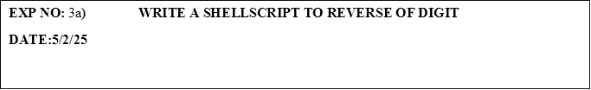

**PROGRAM:**

#!/bin/bash

# Prompt the user to enter a number

echo "Enter a number:"

read num

# Initialize variables

rev=0

# Loop to reverse the number

while [ $num -gt 0 ]

do

    # Get the last digit of the number

    digit=$((num % 10))

    # Add the digit to the reversed number

    rev=$((rev * 10 + digit))

    # Remove the last digit from the number

    num=$((num / 10))

done

# Display the reversed number

echo "Reversed number: $rev"

**OUTPUT:**

Enter a number:

1234

Reversed number: 4321